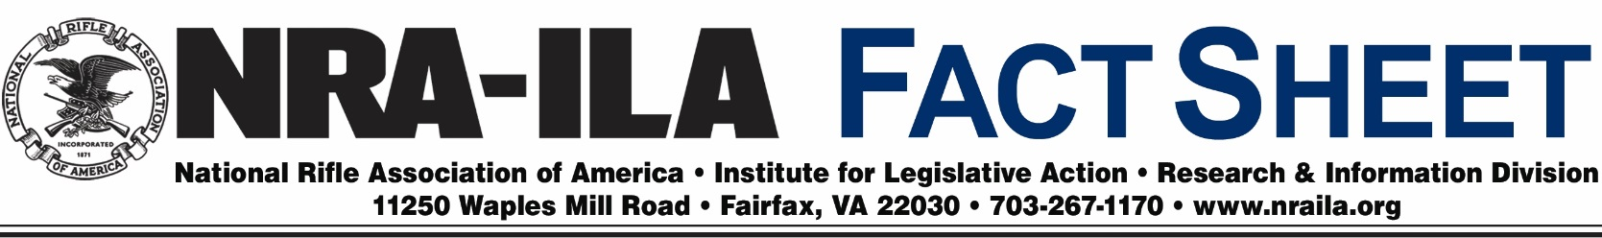
August 8, 2016
The Advantages of Hunting with a Firearm Suppressor
Insufficient hearing protection while shooting can lead to hearing loss, tinnitus, and the need for hearing aids later in life. Hearing protection sufficient to protect against the unsuppressed report of a firearm can make it difficult to hear wildlife movements, changes in the wind, and other sounds in the hunting environment. Using a suppressor reduces the sound of the firearm enough to allow the safe use of minimal hearing protection, depending on the type of firearm and suppressor being used. This allows hunters to be more aware of their surroundings and other hunters in their areas.

The use of suppressors while hunting can also reduce the extent to which the noise of gunfire travels outside hunting areas. Also, because the loud report of an unsuppressed firearm can be startling to new participants, decreasing the report through the use of a suppressor can help young people and others not accustomed to gunfire acclimate themselves to the activity with greater ease while remaining in clear communication with their instructors. Currently, 41 states allow the ownership of suppressors, and 39 states allow suppressors to be used while hunting.

Background—The first suppressor was invented more than a century ago by Hiram Percy Maxim and was commercially sold as a “Maxim Silencer.” The name was a misnomer because no suppressor can completely silence the report of a firearm. Using a system of baffles, suppressors work by allowing the gas from a fired cartridge to remain in the tube, cool down and expand before exiting. Typically, a suppressor reduces the noise of a gunshot by 20–35 decibels, which is approximately the same reduction heard by the shooter when properly wearing earplugs or earmuffs. Each decrease of three decibels reduces the sound by a half.

How Suppressors Are Regulated—Suppressors are federally regulated under the National Firearms Act of 1934 (NFA) and the Gun Control Act of 1968. Currently, suppressors are subject to the NFA’s cumbersome and lengthy application process through the Bureau of Alcohol, Tobacco, Firearms and Explosives (ATF), including approval of the buyer’s chief law enforcement officer in the city or county where the buyer lives, fingerprints and photographs, and the payment of a $200 tax to the IRS.

Ironically, regulation of suppressors is one area where American gun owners are at a relative disadvantage to their counterparts in other countries. Many European nations, for example, place no regulations on their acquisition or use. Ironically, while mufflers are required or commonly included on a various noise-producing tools, such as cars, lawn mowers, and chainsaws, the law discourages their use on firearms.

For additional information on the use of suppressors for hunting, see the NRA All Access video at the following link: https://www.youtube.com/watch?v=8LFZw10pcE8.

