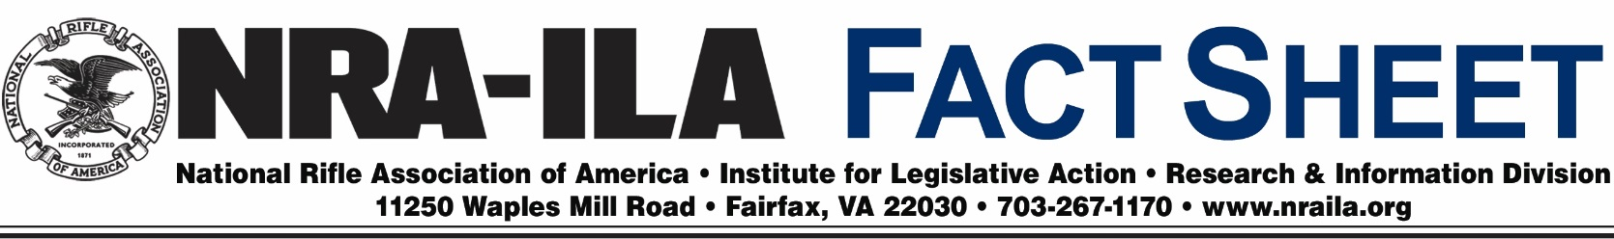
August 8, 2016
Lead Ammunition Used by Hunters
- Lead ammunition has not been scientifically proven to have a population-level impact on wildlife other than waterfowl, or linked to lead poisoning in humans. The available evidence is overwhelmingly clear that traditional ammunition containing lead is still best, and that bans on lead ammunition for big game and small game hunting are ineffective.
- A decrease in the purchase of ammunition would adversely affect conservation funding. Hunters and target shooters are the largest supporters of conservation through excise taxes levied on ammunition, firearms and hunting equipment by the Pittman-Robertson Act of 1937, which has generated more than $7.2 billion in funding for wildlife conservation programs.
- While lead ammunition opponents claim that the ammunition should be banned to prevent occasional lead poisonings in eagles and other raptors, the population of bald eagles—removed from the list of threatened and endangered species in 2007—is at an all-time high. The latest data from the USFWS showed the number of breeding pairs thriving in the United States in 2006 at 9,789 pairs compared to 487 pairs in 1963.
- In the United States, wildlife experts do not manage wildlife based on single mortality incidents or emotions. Our country’s wildlife management practices are based on the North American Model of Wildlife Conservation, which is widely recognized as the best in the world. For more than a century, wildlife in the United States has been successfully managed through this model and has led to an incredible restoration of multiple species.
- A 2008 CDC study on the prevalence of lead in the bloodstreams of 738 residents of North Dakota found levels of lead lower than those in the general population, with 86 percent of those tested reporting that they consumed meat from wild game killed with the use of lead ammunition.
- In 2007, California banned the use of lead ammunition for hunting big game in the California condor zone. Despite 99% hunter compliance, the ban has failed to reduce lead poisoning in condors. It is likely that industrial lead compounds, which are much different from the metallic lead used in ammunition, are responsible for many of the lead poisonings attributed to lead ammunition.
- Contrary to assertions by some lead ammunition opponents, there simply is no credible evidence that definitively links the use of traditional ammunition in upland bird hunting to any decline in wildlife populations.
Today, the use of traditional lead ammunition is under attack by anti-hunting and anti-gun organizations who reject science and misinform policy makers and the public on the effects of lead ammunition commonly used by hunters.

Anti-hunting groups and gun control supporters want lead ammunition banned for hunting to raise the cost of ammunition and, as a result, to dissuade people from participating in hunting and acquiring firearms for that purpose. They attack hunting season by season, species by species, method by method, and they would continue doing so until all traditional ammunition and hunting were banned within the United States. The President and CEO of the Humane Society of the United States, Wayne Pacelle, has been quoted as saying: “We are going to use the ballot box and the democratic process to stop all hunting in the United States. We will take it species by species until all hunting is stopped in California. Then we will take it state by state.”

In the 1980s, the U.S. Fish and Wildlife Service (USFWS) conducted studies to determine the effect of lead shot on waterfowl and raptors. The results persuaded the USFWS to propose phasing out lead shot for waterfowl hunting in zones with a high incidence of eagles consuming waterfowl that were wounded by lead shot or not retrieved.

At that time, bald eagles were listed as an endangered species. In 1985, the National Wildlife Federation sued the USFWS to expand the proposed prohibition, citing violations of the National Environmental Policy Act, the Endangered Species Act, the Migratory Bird Treaty Act, the Bald and Golden Eagle Protection Act and the Administrative Procedure Act. In 1991, the USFWS implemented a nationwide ban on lead shot for waterfowl hunting. The federal regulations apply only to waterfowl—ducks, geese, swans and coots.
Despite the failure of California’s 2007 ban on the use of lead ammunition for big game hunting to reduce lead poisoning in condors, the state’s legislature enacted AB 711 in 2013, expanding the lead ammunition ban statewide following a misleading campaign by anti-hunting organizations. Under AB 711, the ban will apply to all hunting throughout California by no later than 2019.

U.S. Fish and Wildlife Service, Bald Eagle Population Size (March 18, 2013), http://www.fws.gov/midwest/eagle/population/index.html.
Shahed Iqbah, North Dakota Lead Exposure Study, Oct. 14, 2008, http://www.nssf.org/share/PDF/ND_report.pdf.
Hunt for Truth, 5 Yr. Lead Ammo Ban Fails To Reduce Levels of Lead in Condors (August 26, 2013), http://www.huntfortruth.org/5-year-lead-ban-fails-to-reduce-blood-lead-levels-in-california-condors/.
National Wildlife Federation v. Hodel, 15 Envtl. L. Rep. 20891; Civ. No. S-85-0837 EJG (E.D. Cal. August 26, 1985), https://elr.info/sites/default/files/litigation/15.20891.htm.

