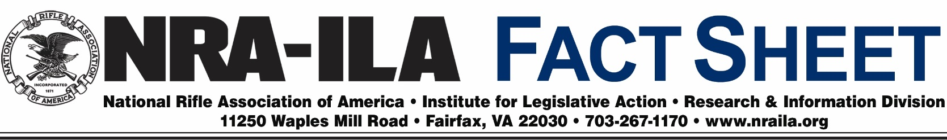
August 8, 2016
Public Access to Private Land Hunting Programs
Finding a place to hunt is one of the biggest challenges hunters face today, and NRA-ILA is actively working on multiple fronts to promote solutions to this growing problem. Each state can help by adopting a program to increase public access to private land. Twenty-six states have public access programs, which provide modest payments to landowners who open up their lands to sportsmen.

Approximately 15 million Americans hunt, contributing more than $38.3 billion to the economy each year, supporting more than 680,000 jobs. Hunting and fishing licenses, permits, stamps and excise taxes on hunting and fishing goods have generated billions of dollars for wildlife conservation, research, and management over the years. By any measure, sportsmen are the single largest contributors to conservation. Public access programs expand the benefits that hunters bring to wildlife and wildlife habitat, and their expansion creates an opportunity to open millions of new acres to hunters, which in turn would positively impact efforts to recruit and retain new hunters in the future.

In addition to state funds and incentives, grants are authorized at the federal level through the Voluntary Public Access and Habitat Incentive Program (VPA-HIP), also known as “open fields.” This program, which has long been supported by the NRA, opens up more hunting land and maintains a strong hunter population in the field. VPA-HIP provides resources to help fund state efforts to develop voluntary incentive programs that expand public access to private lands for hunting, fishing and other recreational purposes.

Through state public access programs, incentives to participating landowners may include tax breaks, discounted hunting and angling licenses, reduced landowner liability and grants for habitat improvement.

This program benefits wildlife as well as hunters and landowners. Grants provide incentives to landowners to improve the habitat for wildlife, an essential initiative for the future of hunting in America. Because these programs are managed by the states, federal grants allow these programs to expand as quickly as possible, while remaining more flexible as individual state programs.

NRA-ILA will continue to promote these programs at the state and federal level. We encourage our members to learn more about the programs offered in their states, and we ask that landowners consider providing public access to their land. If your state does not have a hunter access program in place, we encourage you to contact your elected officials and state fish and wildlife management agency to voice your support for this type of program.

