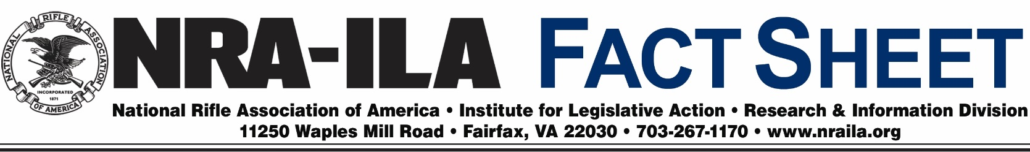
August 8, 2016
The Pittman-Robertson Act’s Support to Wildlife

It may be hard to believe today, but in the 1930s the sighting of even one whitetail deer was a notable event. Expansion of the U.S. population into game habitat areas and over-hunting without regulation had caused populations of many game species to plummet. Today, however, the nationwide deer population is nearly 32 million strong. Similar increases have taken place among ducks and wild turkeys.
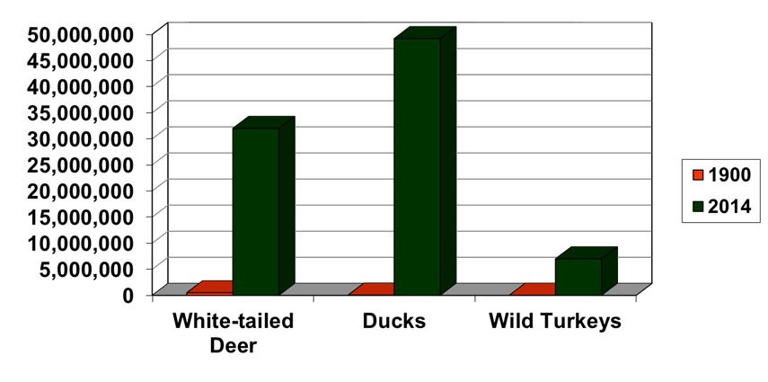

The conservation programs that helped restore game species populations are largely funded by the Federal Aid in Wildlife Restoration Act of 1937, commonly known as the Pittman-Robertson Act, which derives its revenues from sportsmen. In 1950, following the model set by Pittman-Robertson, Congress passed the Federal Aid in Sport Fish Restoration Act, commonly known as the Dingell-Johnson Act. Revenue generated from excise taxes on fishing equipment sales goes toward restoring and improving America’s fishery resources.

Pittman-Robertson imposes an 11% excise tax on long guns, ammunition and archery equipment, and a 10% excise tax on handguns. Revenue is deposited in a special trust fund under the management of the U.S. Fish and Wildlife Service to be used for state wildlife restoration projects. One-half of the tax revenue collected on handguns and archery equipment may be used by state fish and wildlife agencies for hunter safety training and range development. Over the years, the Act has collected nearly $7.2 billion to fund conservation efforts across the country.

Sportsmen are the primary supporters of efforts to protect game species. Conservation efforts fueled by Pittman-Robertson funds, such as the acquisition and improvement of wildlife habitat, wildlife species introduction, wildlife research, public access programs, and hunter education programs, along with state wildlife agencies that carefully regulate hunting, have helped restore and now conserve America’s abundant wildlife population.

See the FY2016 fund apportionment at http://wsfrprograms.fws.gov/Subpages/GrantPrograms/WR/WRFinalApportionment2016.pdf.

